**Gallery of Teaching Applications**

**Title**: Thermo-mechanical analysis of structures under fire using OpenSeesPy

**Target audience**: Graduate students in Structural and Mechanical Engineering with basic knowledge of programing, linear and nonlinear structural analysis, and heat transfer.

**Learning objectives**:

* Introduction to building fires
* Description of time - gas temperature fire curves and fire loads
* Material properties at elevated temperatures
* Principles of thermo-mechanical analysis

**List of tools**:

* OpenSeesPy
* Google Colab (or other installations for Jupyter notebooks). Google Colab is one of the most convenient ways to do notebook scripting on Python since it requires no local installations and uses free cloud computations resources.

**Supplemental material**:

* OpenSeesPy documentation: <https://openseespydoc.readthedocs.io/>
* ‘OpenSees For Fire’ documentation and tutorials: <https://openseesforfire.github.io/>
* Google Colab introduction: <https://youtu.be/inN8seMm7UI>
* Jupyter using a Colab Notebook: <https://colab.research.google.com/notebooks/intro.ipynb>
* Python basics: <https://nheri-simcenter.github.io/SimCenterBootcamp2020/source/lecture_videos_part1.html>
* OpenSeesPy documentation: <https://openseespydoc.readthedocs.io/>
* OpenSees command manual:<https://opensees.berkeley.edu/wiki/index.php/Command_Manual>
* OpenSees: A Comprehensive Overview video: <https://www.youtube.com/watch?v=X78FIsZQ330>

**Assignment**: Parametric study of a beam under gravity loading and fire:

(a) Utilization (demand-to-capacity) ratio (b) Mesh refinement, (c) thermal gradient

Consider a 9-meter IPE330 beam with pinned-pinned boundary conditions at beam ends as seen in Figure 1. The beam is discretized with 10 elements along the beam length. The cross section is discretized with 14 and 10 fibers along web and flange width, respectively. There are 2 fibers across the web and flange thickness. The beam is subjected to 10kN/m uniformly distributed load and then to 30-minute ASTM E119 (ISO834) Standard fire on all sides except the top flange, which is sealed by a concrete slab (i.e. 3-sided heating). Assume a simplified temperature distribution across IPE330 section as shown in Figure 2, where the temperature gradient is linear, and the temperature is ramped up from 20 °C (ambient) to 825 °C in the bottom flange and from 20 °C to 690 °C in the top flange in 30 minutes (i.e. end of fire).

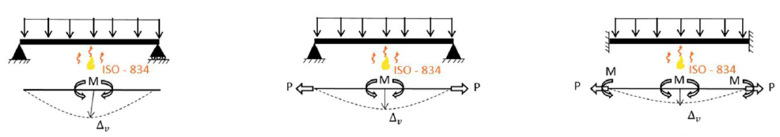

Figure 1. Beam with pinned-pinned boundary restraints.

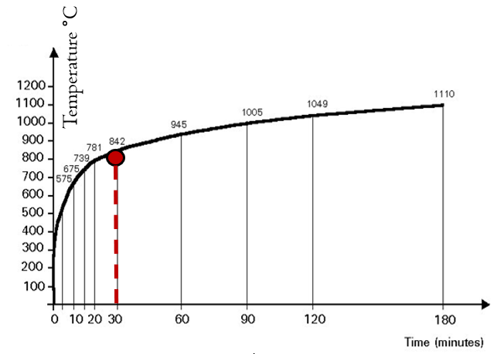 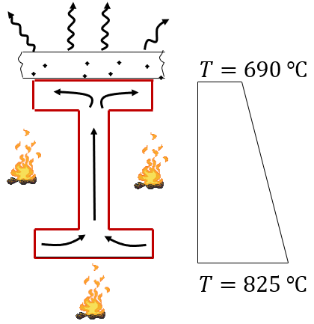

(a) (b)

Figure 2. (a) Standard fire time-temperature curve, (b) assumed temperature distribution across the beam cross-section at 30 minutes of standard fire exposure.

**Starter code**

The model generation, analysis and post-processing are coded in OpenSeesPy using Jupyter Notebook. Your starter code is beamExercise.ipynb, which represents a 9-meter IPE330 beam (10 elements) with pinned-roller supports.

**(a) Conduct a loading utilization study:**

Start with a pinned-pinned beam and change the uniformly distributed load (UDL) on the beam from 10 kN/m to 1 kN/m and 0.1 kN/m. Note that the units in the script are meters, Newtons and Degree Celsius °C.

Compare and comment on the changes of fire response of the beam with low and high utilization ratios. You need the axial force, midspan moment and midspan vertical deflection plots. Here, you will consider the stiffness and strength reduction of steel material, the induced axial force due to the translational restraint on beam ends, the midspan (vertical) deflection rate and the second-order effects.

**(b) Conduct a mesh refinement study:**

First, change the boundary condition to pinned-pinned. Run the code with **2** elements and **16** elements along the beam length; **7** and **21** fibers along the beam web (depth). Compare and comment on the changes of fire response of the beam with different fiber- and element discretization. Do you see any difference with mesh refinement across the section and along the beam length?

**(c) Conduct a thermal gradient study:**

The bottom flange temperature in the Stater code is ramped up to 825 °C and the top flange is ramped up to 690 °C. This is 758 °C average section temperature at the end of 30 minutes (i.e. $(825+690)/2$). The thermal gradient across IPE330 beam depth is therefore ramped up to **410 °C/m** (i.e. $(825-690)/0.330$). Run the code for zero thermal gradient **0 °C/m** by ramping the bottom and top flange temperatures up to 758 °C (i.e. uniform temperature increase across the beam depth). Compare and comment on the changes of fire response of the beam with and without the thermal gradient. Here, you need to discuss the induced moment due to the shift of the resultant internal axial force towards the cooler region on the cross section.