Gallery of Teaching Applications
Module: Nonlinear response history analyses of structures

Title: Nonlinear response history analyses of structures

Target audience: Graduate students in Structural Engineering with basic knowledge of programing, linear and nonlinear structural analysis.

Learning objectives:
- Introduce the concept of nonlinear response history analysis (NLRHA).
- Describe the general computational workflow for NLRHA.
- Learn the basic requirements for ground motion selection and scaling.

List of tools:
- OpenSees
- SimCenter EE-UQ

Supplemental material:
- Download link EEUQ: https://www.designsafe-ci.org/data/browser/public/designsafe.storage.community//SimCenter/Software/EE_UQ
- Training videos EEUQ: https://simcenter.designsafe-ci.org/research-tools/ee-uq-application/

Activity description:

Figure 1 and Figure 2 shows the geometry of an existing special steel moment frame building located in a high seismic hazard region. You are responsible for evaluating the seismic performance of this frame using nonlinear response history analyses.
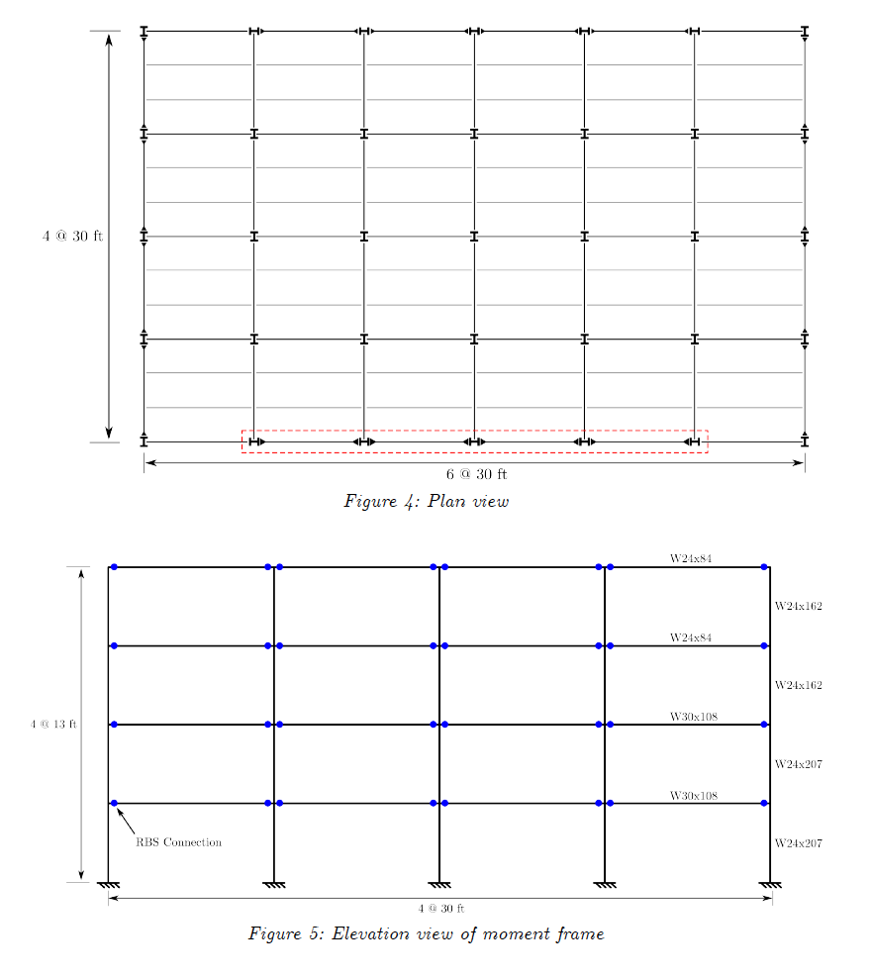
Figure 1. Plan View of Building
Figure 2. Elevation of RBS Moment Frame

The perimeter frame in the E-W direction highlighted in Figure 1 is idealized as a 2D OpenSees model. The main script of the model is part of the starter code (“MRF_4Story_Concentrated_model.tcl”). Figure 3 shows the elevation view of the model with node numbers. The model has a leaning column that carries the dead and live load that is stabilized by the frame. The end of the beams have elastic-plastic concentrated plastic hinges (Zz*Fy,exp) that account for the reduced beam section at the hinge locations, and assume “expected” (as opposed to minimum specified) material properties. The vertical dead load (DL) and live load (LL) are applied using the load factors specified in ASCE/SEI 41 (1.1*(DL + 0.25LL)). The first-mode period calculated with OpenSees is 1.12 s.

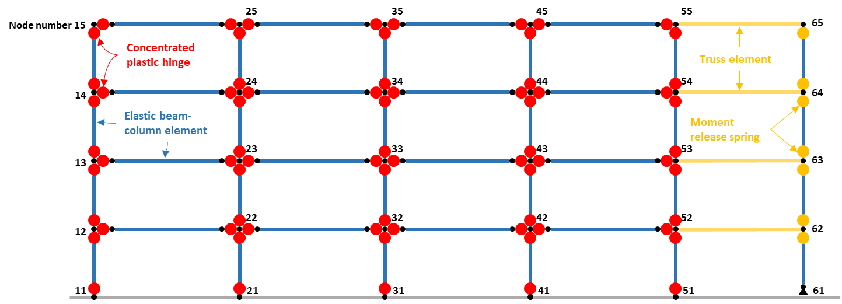
Figure 3. Schematic plot of the concentrated plastic hinge model for the 4-story steel moment frame.

In order to estimate the structural response demands (e.g., peak story drift ratio, peak floor acceleration), you will conduct the nonlinear response history analysis following the ASCE/SEI 7 using the SimCenter tool EE-UQ. Major steps are listed as follows for your reference:

- Specify the number of samples: click on the “UQ” tab of EE-UQ and in the “# Sample” box, fill in the number of selected ground motion records so that the program would analyze the building under all motions (11 ground motions per ASCE/SEI 7).
- Load the OpenSees model: click on the “SIM” tab on the left menu of the EE-UQ and select the “OpenSees” as the “Building Model Generator”. Choose the main script (MRF_4Story_Concentrated_model.tcl) as the “Input Script”. For “Response Nodes” whose responses will be recorded during time history analyses, please specify the nodes of one “column line” from Figure 3 (e.g., 11, 12, 13, 14, 15) so the program will automatically compute and report the story drift ratios. Make sure the damping ratio for the structure is 5% to align with the definition of the target response spectrum.
- Select and scale ground motion records for DBE and MCEr target spectra. Remember that DBE is 2/3 of the MCEr spectrum, where the MCEr ordinates at this site are S_{s} = 1.5g and S₁ = 0.6g.
For ground motion selection in EEUQ you shall click on the “EVT” (event) tab and select the “PEER NGA Records” as the “Load Generator”. Select the target spectrum type as “Design Spectrum (ASCE 7-10)” and specify the corresponding spectral values for DBE or MCE. EEUQ selects ground motions for one target spectrum at the time.

Request 11 records and leave the default values for the remaining selection criteria. Since this is a 2D model, specify H1 or H2 as the acceleration component to select and scale ground motions based on one horizontal component only. Use the “Minimize MSE” as the scaling method and specify the period range (0.2T₁ to 1.5T₁) for selecting and scaling ground motions. Use the period (T₁) estimated in problem 1. Then click on “Select Records” to gather the ground motion suite.

- Specify the nonlinear response history analysis script: click on the “FEM” tab on the left menu and choose the “MRF_4Story_Concentrated_solver.tcl” as the “Analysis Script”. This script is created for solving the nonlinear response history analysis in this assignment but also could be used for solving other OpenSees models.

- Run the nonlinear response history analyses (NLRHAs). This problem only considers uncertainty in the ground motions. You can perform this runs locally or remotely on the Texas Advanced Computing Center (TACC) using the option to “RUN at DesignSafe”. Note that you will need to register at DesignSafe for this (https://www.designsafe-ci.org/account/register/). The recommended settings for 11 NLRHAs ran in DesignSafe are shown in Figure 4.

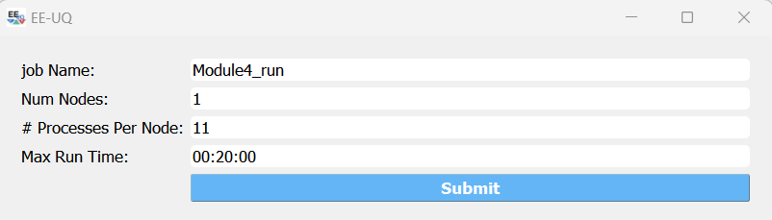
Figure 4. Recommended settings for job on DesignSafe

To monitor the status of your run and retrieve the data from the server when the RUN at DesignSafe is finished, click on the “Get from DesignSafe” button. This will show you the list of all your pending runs including the job name and the status. When the status column marks “finished”, retrieve the data by right clicking the status to open the option menu and select “retrieve data”.

Save the engineering demand parameters (EDPs) results after retrieving the data using the “Save Table” button in the “Data Values” section on the “RES” tab.

- Summarize the results in the following figures:
- A plot of the response spectra of selected and scaled ground motion records.
- Save the analysis data from EE-UQ, and then post process the data with following outputs.
  - A plot of the peak inter-story drift ratios (PID) and their average, median, and dispersion.
  - A plot of the peak floor acceleration (PFA) and their average, median, and dispersion.
  - The maximum PID and PFA of the median profile along the building height.
- Comment on your results. Do you think that this building is safe? Why? How do the NLRHA results relate to the pushover results from Module No. 3?

Starter code
Model and test files
The folder “StarterCode” includes the following files in the proper format to use in EEUQ:

MRF_4Story_Concentrated_model.tcl = OpenSees model of the frame
SolverPushover.tcl = OpenSees routine to solve the nonlinear static analysis. Note that this file is incomplete, and you must fill the gaps.

Postprocessing notebooks
To facilitate your work, you can use the Google Colab notebook “post_process_NLRHA_EEUQ. ipynb” to produce the plots required in this module.

Note that you need to manually zip the results from the NLRHAs performed by EEUQ. These results are typically stored in the following local folder:

EEUQ working directory: \..Documents\ EEUQ \LocalWorkDir

The exact location can be found by clicking “File”, “Preference”, and searching on the “Local Jobs directory” line on the pop-up window.

Upload the zip file to the notebook environment using the “Choose Files” button:

