**Gallery of Teaching Applications**

**Title**: Thermo-mechanical analysis of structures under fire using OpenSeesPy

**Target audience**: Graduate students in Structural and Mechanical Engineering with basic knowledge of programing, linear and nonlinear structural analysis, and heat transfer.

**Learning objectives**:

* Introduction to building fires
* Description of time - gas temperature fire curves and fire loads
* Material properties at elevated temperatures
* Principles of thermo-mechanical analysis

**List of tools**:

* OpenSeesPy
* Google Colab (or other installations for Jupyter notebooks). Google Colab is one of the most convenient ways to do notebook scripting on Python since it requires no local installations and uses free cloud computations resources.

**Supplemental materials**:

* OpenSeesPy documentation: <https://openseespydoc.readthedocs.io/>
* ‘OpenSees For Fire’ documentation and tutorials: <https://openseesforfire.github.io/>
* Google Colab introduction: <https://youtu.be/inN8seMm7UI>
* Jupyter using a Colab Notebook: <https://colab.research.google.com/notebooks/intro.ipynb>
* Python basics: <https://nheri-simcenter.github.io/SimCenterBootcamp2020/source/lecture_videos_part1.html>
* OpenSeesPy documentation: <https://openseespydoc.readthedocs.io/>
* OpenSees command manual:<https://opensees.berkeley.edu/wiki/index.php/Command_Manual>
* OpenSees: A Comprehensive Overview video: <https://www.youtube.com/watch?v=X78FIsZQ330>

**Exercise**: Parametric study of a beam under gravity loading and fire:

Restraint conditions

Consider a 9-meter IPE330 beam with pinned-roller, pinned-pinned and fixed-fixed boundary conditions at beam ends as seen in Figure 1. The beam is discretized with 10 elements along the beam length. The cross section is discretized with 14 and 10 fibers along web and flange width, respectively. There are 2 fibers across the web and flange thickness. The beam is subjected to 10kN/m uniformly distributed load and then to 30-minute ASTM E119 (ISO834) Standard fire on all sides except the top flange, which is sealed by a concrete slab (i.e. 3-sided heating). Assume a simplified temperature distribution across IPE330 section as shown in Figure 2, where the temperature gradient is linear, and the temperature is ramped up from 20 °C (ambient) to 825 °C in the bottom flange and from 20 °C to 690 °C in the top flange in 30 minutes (i.e. end of fire).

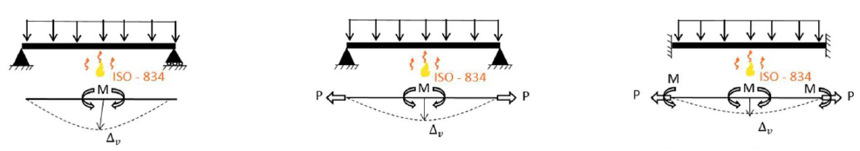

(a) (b) (c)

Figure 1. Beam with (a) pinned-roller, (b) pinned-pinned, (c) fixed-fixed boundary restraints.

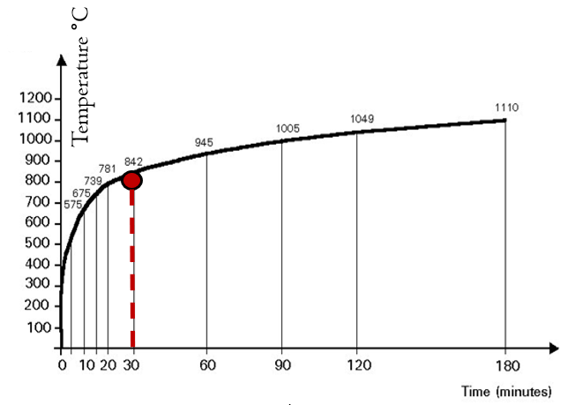 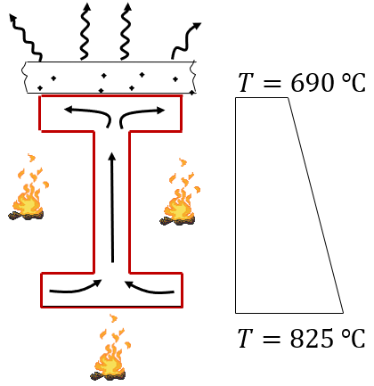

(a) (b)

Figure 2. (a) Standard fire time-temperature curve, (b) assumed temperature distribution across the beam cross-section at 30 minutes of standard fire exposure.

**Starter code**

The model generation, analysis and post-processing are coded in OpenSeesPy using Jupyter Notebook. Your starter code is BeamExercise.ipynb, which represents a 9-meter IPE330 beam (10 elements) with pin-roller supports.

**Conduct a boundary restraint study:**

Change the boundary conditions from pinned-roller to pinned-pinned and fixed-fixed and run the code. Plot the axial force (*kN*), midspan moment (*kN.m*) and midspan deflection (*m*) of the beam with respect to time (minutes) as discussed in the lecture.

Compare and comment on the changes of fire response of the beam with different boundary conditions. You need the axial force, midspan moment and midspan vertical deflection plots. Here, you will consider the stiffness and strength reduction of steel material, the induced axial force due to the translational restraint on beam ends, the midspan (vertical) deflection rate and the second-order effects.