Gallery of Teaching Applications
Module: Uncertainty in nonlinear static analyses of structures

Title: Uncertainty in nonlinear static analyses of structures

Target audience: Graduate students in Structural Engineering with basic knowledge of programing, linear and nonlinear structural analysis.

Learning objectives:
- Introduce the concept of nonlinear static analysis (NSA).
- Describe the general computational workflow for NSA.
- Quantify uncertainty in the nonlinear response of structures.

List of tools:
- OpenSees
- SimCenter quoFEM

Supplemental material:
- OpenSees tcl implementation basics: https://youtu.be/5VW18DVyI00
- Download link quoFEM: https://www.designsafe-ci.org/data/browser/public/designsafe.storage.community//SimCenter/Software/quoFEM
- Training videos quoFEM: https://simcenter.designsafe-ci.org/research-tools/quofem-application/.

Activity description:

Figure 1 and Figure 2 shows the geometry of an existing special steel moment frame building located in a high seismic hazard region. You are responsible for evaluating the seismic performance of this frame following the ASCE/SEI 41 provisions using the static nonlinear procedure (2nd-order inelastic analysis).

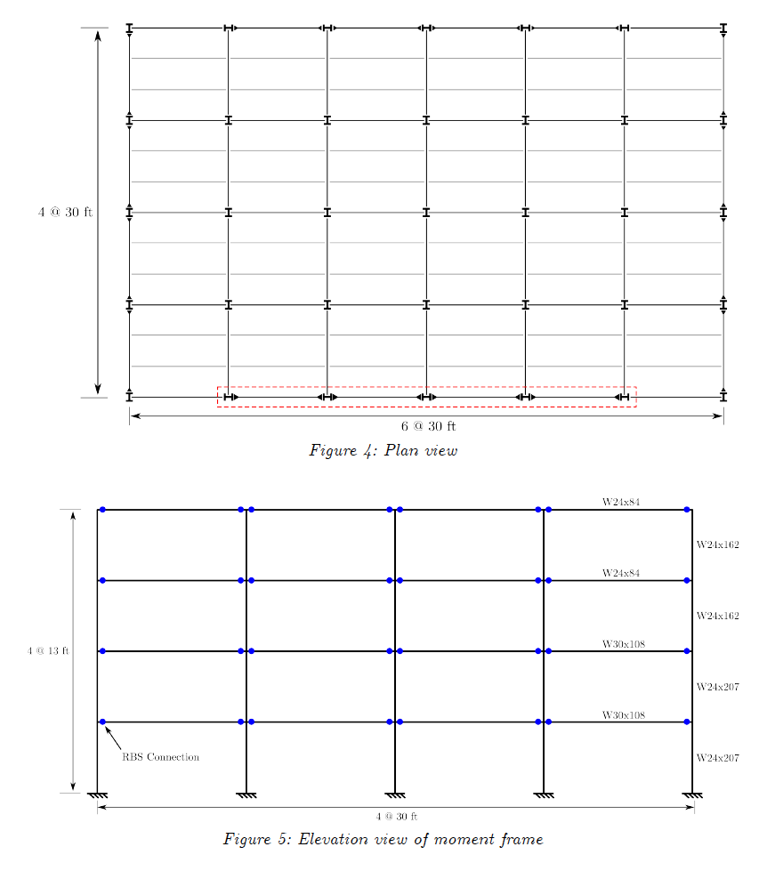
Figure 1. Plan View of Building
Figure 2. Elevation of RBS Moment Frame

The perimeter frame in the E-W direction highlighted in Figure 1 is idealized as a 2D OpenSees model. The main script of the model is part of the starter code (“MRF_4Story_Concentrated_model.tcl”). Figure 3 shows the elevation view of the model with node numbers. The model has a leaning column that carries the dead and live load that is stabilized by the frame. The end of the beams have elastic-plastic concentrated plastic hinges (Zz*Fy,exp) that account for the reduced beam section at the hinge locations, and assume “expected” (as opposed to minimum specified) material properties. The vertical dead load (DL) and live load (LL) are applied using the load factors specified in ASCE/SEI 41 (1.1*(DL + 0.25LL)).

The first-mode period calculated with OpenSees is 1.12 s. The total weight of the building is 5141 kips and all floors have the same weight.

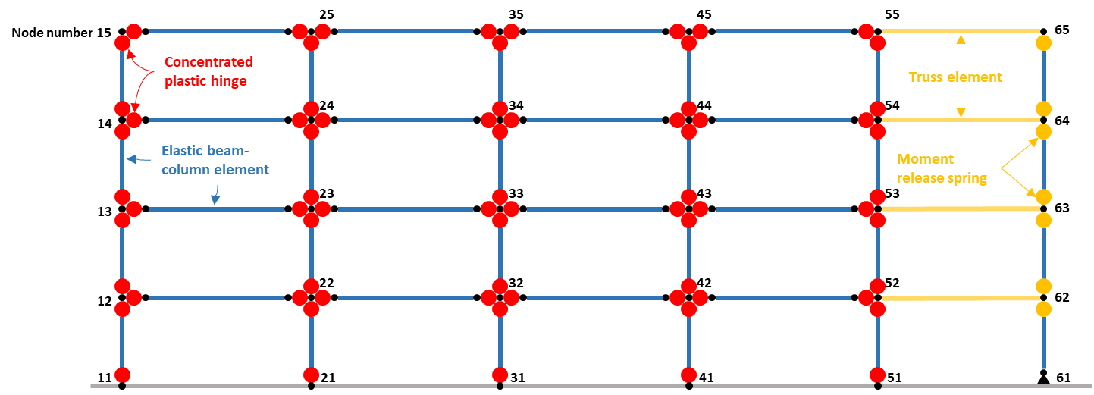
Figure 3. Schematic plot of the concentrated plastic hinge model for the 4-story steel moment frame.

- The first step of the process is completing the relevant parts of the OpenSees model by following the next steps:
- Construct the DBE spectrum per ASCE/SEI 7 (Chapter 11) and calculate the design base shear (V_{design}) for the frame. Remember that DBE is 2/3 of the MCEr spectrum, where the MCEr ordinates at this site are S_{s} = 1.5g, S₁ = 0.6g, F_{a} = 1.0, and F_{v} = 1.50. Assume that V_{design} = V_{DBE,elastic}/R, where R = 8.0 (response modification factor for special steel moment frames).
- Calculate the specified roof target displacement per ASCE/SEI 41 Eq. 7-28 for DBE and MCEr intensities. For this assignment, you can assume C₀=1.3 and C₁=C₂=1.0, but you should familiarize yourself with how these are determined.
- Set the maximum roof displacement for the pushover analysis in the “SolverPushover.tcl” file as 1.20 times the MCEr target displacement.
- Complete the lateral load pattern in the “SolverPushover.tcl” file using the force distribution per ASCE/SEI 41 Eqs. 7-24 and 7-25 (similar to basic pattern in ASCE 7-16). This is the lateral force that will be increased to push the frame sideways.

- Calculate the nominal pushover curve of the frame using quoFEM and analyze the structure’s seismic performance.
- Set the UQ Engine to Dakota with Forward Propagation using Latin Hypercube Sampling (LHS). Use 1 sample and any seed value.
- Choose OpenSees as FEM application and choose the appropriate model script provided in the StarterCode folder (MRF_4Story_Concentrated_model.tcl) and the solver script that you already completed.
- Assign a very low standard deviation (e.g., 0.01) to each of the random variables in the RV tab.
- The EDP of interest in quoFEM in the envelope drift on the first story. Thus, specify “drift” with a length of 3 in the EDP tab. The length is 3 because the standard OpenSees output for envelope recorders includes 3 numbers: maximum, minimum, and absolute maximum.
- Run the analysis and save the output files “baseShear.out”, “Gravity.out”, “story1_disp.out”, “story2_disp.out”, “story3_disp.out”, and “story4_disp.out” that you can find in the quoFEM running folder.
The quoFEM running folder is usually found at:
..\Documents\quoFEM\LocalWorkDir\tmp.SimCenter\
- Use the post-processing notebook provided in Google Colab to plot the roof displacement versus base shear and the roof drift versus base shear coefficient (nominal pushover curve). Make sure that the plot of the pushover shows the following:
- A vertical line at the roof target displacements corresponding to DBE and MCEr that you computed in 1c following ASCE/SEI 41.
- A vertical line at the roof displacement corresponding to the maximum lateral force on the pushover.
- A horizontal line at the value of V_{design}.
- Report the calculated overstrength factor, the DBE roof drift ratio, and the DBE drift ratio for each story.
- Provide a short (1 paragraph) written summary of the building’s seismic performance. How do you think the building would behave for the DBE? the MCEr? Does the overstrength aligns with building code assumptions?

- The owner of the building is debating between three experimental campaigns for collecting samples and testing material properties (Table 1). To aid the owner’s decision, you need to quantify the uncertainty in the pushover curve and associated seismic performance of the frame for each experimental campaign.

Table 1. Alternative experimental campaigns for the frame
Experimental campaign | Level of uncertainty in material properties | Assumed coefficient of variation (COV) of the parameters
Detailed | Low | 0.10
Moderately detailed | Medium | 0.30
Minimum | High | 0.50

- Repeat the analyses described in numeral 2) but using 100 samples for Forward Propagation. In the RV tab, keep the default mean value for each variable but replace the distribution type to lognormal and calculate the standard deviation using the corresponding COV for each experimental campaign (see example in Figure 4).

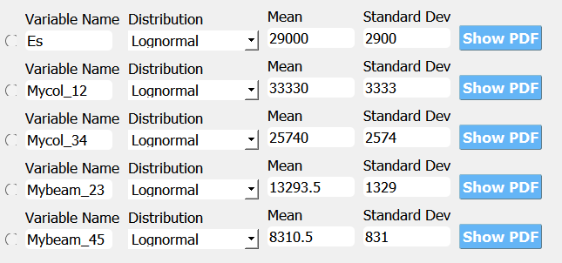
Figure 4. Random variable inputs for the Detailed experimental campaign for a COV=0.10 on all variables

- Plot the multiple pushover curves for each of the experimental campaigns in and superimpose the nominal pushover curve that you computed in (2). Provide one figure for each experimental campaign. To create these plots, use the post-processing notebook provided in Google Colab. You need to provide the quoFEM results in a zip file containing the folders for each of the simulations that you can find in the quoFEM working directory. Create the pushover curves for each experimental campaign one at a time.
- Provide a short (1 paragraph) written analysis of the results including your recommendations for the experimental campaign that the owner should consider.

Starter code
Model and test files
The folder “StarterCode” includes the following files in the proper format to use in quoFEM:

MRF_4Story_Concentrated_model.tcl = OpenSees model of the frame
SolverPushover.tcl = OpenSees routine to solve the nonlinear static analysis. Note that this file is incomplete, and you must fill the gaps.

Postprocessing notebooks
To facilitate your work, you can use the Google Colab notebook “post_process_push_quoFEM.ipynb” to produce the plots required in this module.

Note that you need to manually upload the results for the nominal pushover curve (problem 2) using the “Choose Files” button in the notebook:
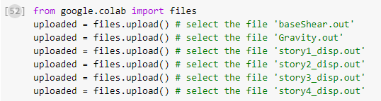

You also need to manually zip the results from each of the simulations performed by quoFEM in problem 3. These results are typically stored in the following local folder:

quoFEM working directory: \..Documents\quoFEM\LocalWorkDir

The exact location can be found by clicking “File”, “Preference”, and searching on the “Local Jobs directory” line on the pop-up window.

You need to upload this zip file to the notebook environment using the “Choose Files” button:

