**Gallery of Teaching Applications**

**Module: Nonlinear simulation of structures using OpenSees**

**Title:** Nonlinear simulation of structures using OpenSees

**Target audience:** Graduate students in Structural Engineering with basic knowledge of programing, linear and nonlinear structural analysis.

**Learning objectives:**

* Compare the most common models for nonlinear simulation of structural members.
* Present the Open System for Earthquake Engineering Simulation (OpenSees).
* Develop an OpenSees model using notebook scripting.

**List of tools:**

* OpenSeesPy
* Google Colab (or other installations for Jupyter notebooks). Google Colab is one of the most convenient ways to do notebook scripting on Python since it requires no local installations and uses free cloud computations resources.

**Supplemental material:**

Google Colab introduction: <https://youtu.be/inN8seMm7UI>

Jupyter using a Colab Notebook: <https://colab.research.google.com/notebooks/intro.ipynb>

Python basics: <https://nheri-simcenter.github.io/SimCenterBootcamp2020/source/lecture_videos_part1.html>

OpenSeesPy documentation: <https://openseespydoc.readthedocs.io/>

OpenSees command manual:<https://opensees.berkeley.edu/wiki/index.php/Command_Manual>

OpenSees: A Comprehensive Overview video: <https://www.youtube.com/watch?v=X78FIsZQ330>

**Activity description:**

Shown below is a diagram of a steel eccentrically braced frame (EBF) and a reinforced concrete coupled shear-wall. The circled member in the EBF is the “link” while the circled member in the coupled shear wall is one of the coupling beams. These important members concentrate most of the nonlinear response of the structure during strong lateral loads.

You will complete three different OpenSees models of these members to evaluate their behavior using different simulation assumptions. Please report the results on the answer sheet provided with the homework. The link or coupling beam can be modeled using a unique line element as the one shown in figure (c) provided that the length of the member (*L*) is greater or equal to 4 times the depth of the cross-section. This model assumes that the member has only one degree of freedom that represents the total vertical deformation. The link in the EBF has *L*=100in. The beam is a W18X60 steel section with E=29,000 ksi and *Fy* = 50 ksi.



*Plastic hinge model*

1. Calculate the elastic stiffness (*K*), the shear capacity of the section (*Vn*), the plastic moment of the section (*Mp*), the plastic shear demand of the member (*Vp*), and the yielding displacement (*δy*) using basic structural analysis ignoring shear deformation and geometric nonlinearities for simplicity. Is the member controlled by shear or flexure?
2. Complete the OpenSees model of the link that uses an elastic element with one plastic hinge at each end. Assume that the hinges have the trilinear backbone curve shown in the figure below (this backbone curves are estimated with full-scale tests of steel members). Note that the elastic stiffness of the hinge is assumed to be 10 times larger than the stiffness of the elastic element, and the modulus of elasticity is modified by 1.10. These adjustments ensure that the elastic stiffness of the model matches the hand calculations in (a). The backbone curves can be represented using the Hysteretic material in OpenSees.

Rotation [rad]

Moment

Mp

0.02

0.06

10 (6EmodI/L)

Symmetric backbone of the rotational springs

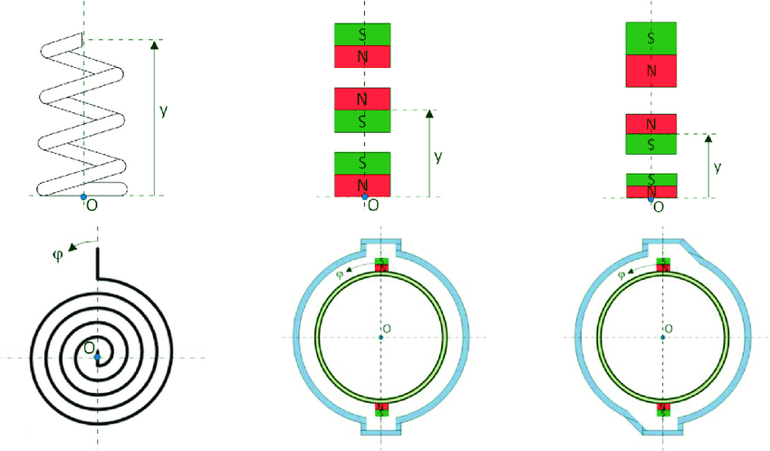

Emod = 1.1E

0.9Vp

Mp/10

Onset of degradation

Report the vertical displacement of the model subjected to a force equal to 0.9*Vp*. Compare the stiffness model with your hand calculations.

Modify the model to include shear deformation and PDelta effects. Report the vertical displacements for each case using a force equal to 0.9*Vp*. How important is the effect of shear deformations or PDelta effects on this member?

1. Plot the shear force vs vertical displacement of the member using a displacement-controlled analysis from 0 to 7 in. Report the minimum and maximum axial force in the elastic element. How much is the total displacement at the onset of degradation? Could you calculate that displacement manually? How?

*Fiber-section lumped plasticity model*

The plastic-hinge model used in the previous section assumes that axial and bending demands are completely decoupled, which may not be the case. To overcome this limitation, replace the element and plastic hinges by an elastic element with fiber sections at both ends that explicitly simulate the cross section of the member with multiple uniaxial area elements or fibers (OpenSees provides the forceBeamColumn element with modified Gauss-Radau integration for this purpose). Assume that plasticity spreads on each end a length equal to *h*/2. Discretize the W-section of this member as shown below. Assume that the fibers are made of an elastic-perfectly plastic material (for example, using Steel01 uniaxial material model in OpenSees). Note that this assumption means that the element never degrades its strength.

0000

0

0000

0

0

0000

0

$$t_{f}$$

$$t_{w}$$

$$b_{f}$$

$$h$$

Discretize the flange with 1 fiber and the web with 7 fibers.

1. Report the vertical displacement of the model subjected to a shear force equal to 0.9*Vp* and verify that the elastic stiffness matches your calculations. Do not worry about differences smaller than 8% but comment about the reasons that may explain such differences.
2. Plot the shear force vs vertical displacement of the member using a displacement-controlled analysis from 0 to 7 in. Report the minimum and maximum axial force in the right-most element. What are the differences of this model with the results of part (c)?

*Distributed plasticity model*

The previous lumped plasticity models assume that nonlinear behavior occurs only at the end of the members which requires important assumptions of backbone curves or plastic length. Experimental observations show that plasticity may spread along the element, which invalidates the assumptions of the previous models. To capture this spread of plasticity, you will model the link with a displacement-based element.

Create an OpenSees model of the link using a single DispBasedElement (assume Lobatto integration and 5 integration points). Note that the formulation of the DispBasedElement does not include shear deformations.

1. Report the vertical displacement of the model subjected to a shear force equal to 0.9*Vp* and verify that the elastic stiffness matches your calculations.
2. Plot the shear force vs vertical displacement of the member using a displacement-controlled analysis from 0 to 7 in. Report the minimum and maximum axial force in the right-most element. How does the model results compare with your hand calculations?
3. Modify your model to discretize the member with 5, 10, and 15 DispBasedElements. Plot the shear force vs vertical displacement of the member using a displacement-controlled analysis from 0 to 7 in. Report the minimum and maximum axial force in the right-most element. Comment on the effect of discretizing the model. How many DispBasedElements do you recommend for discretization?

Modify your model to consider strength degradation assuming that the steel material can buckle under compressive stress. To do this, replace the Steel01 material for a Hysteretic material that follows the stress-strain curve shown below.

1. Discretize the member with 5, 10, and 15 DispBasedElements. Plot the shear force vs vertical displacement of the member using a displacement-controlled analysis from 0 to 7 in. Report the minimum and maximum axial force in the right-most element. What is the effect of material degradation on the axial force on the member? Is this realistic? Why?

How many DispBasedElements do you recommend for discretization?

1. Release the horizontal degree of freedom of the right node and repeat the displacement-controlled analysis. Compare your results with those in (g). What is the effect of releasing the horizontal degree of freedom? Why?

ε

σ

Fy

-30εy

40εy

E

Degrading steel material

-Fy

εy = Fy/E