Answer sheet Module: Nonlinear simulation of structures using OpenSees
 | Required result
(a) | K =  Mp =  Vp =  dy =  Vn =  Is the member controlled by shear or flexure? =
(b) | Disp. for 0.9Vp =  K_{model} =  K/ K_{model} =  Considering shear deformation (no PDelta):  Disp. for 0.9Vp =  K_{model} =  K/ K_{model} =  Considering PDelta effects (no shear deformation):  Disp. for 0.9Vp =  K_{model} =  K/ K_{model} =  Importance of shear deformation and/or PDelta effects? =
(c) | 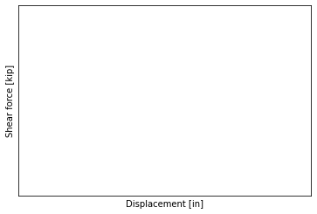  P max =  P min =  Total displacement at the onset of degradation =  Comment about total displacement at the onset of degradation =
(d) | Disp. for 0.9Vp =  K_{model} =  K/ K_{model} =  Why the difference with theoretical value? =
(e) | P max =  P min =  Differences with part (c)? =
(f) | Disp. for 0.9Vp =  K_{model} =  K/ K_{model} =
(g) | P max =  P min =  Comment about the model results and hand calculations =
(h) | 5-element discretization:  P max =  P min =  10-element discretization:  P max =  P min =  15-element discretization:  P max =  P min =  Comment element discretization =  How many elements would you recommend? Why? =
(i) | 5-element discretization:  P max =  P min =  10-element discretization:  P max =  P min =  15-element discretization:  P max =  P min =  What is the effect of material degradation on the axial force on the member? Is this realistic? Why? =  How many elements would you recommend? Why? =
(j) | 5-element discretization:  P max =  P min =  10-element discretization:  P max =  P min =  15-element discretization:  P max =  P min =  What is the effect of releasing the horizontal degree of freedom? Why? =

