Answer sheet Module: Uncertainty in nonlinear static analyses of structures
 | Required result
1a | 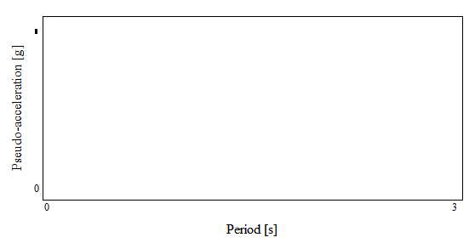  V_{desgin} =
1b | ASCE/SEI 41  roof target displacement DBE =  roof target displacement MCEr =
1c | Lateral load patter per ASCE/SEI 41
2f | 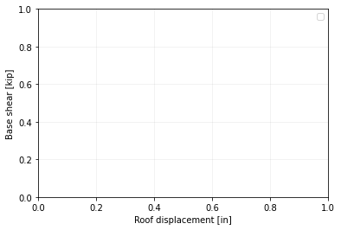  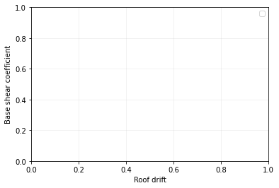
2g | Calculated overstrength factor =  DBE roof drift ratio =  DBE story 4 drift ratio =  DBE story 3 drift ratio =  DBE story 2 drift ratio =  DBE story 1 drift ratio =
2h | Building seismic performance assessment:
3b | Pushover curves for COV = 0.10 for all random variables  Pushover curves for COV = 0.30 for all random variables  Pushover curves for COV = 0.50 for all random variables
3c | Analysis of the results including your recommendations for the experimental campaign that the owner should consider:

